S-Cam Spy Keyring

User Manual

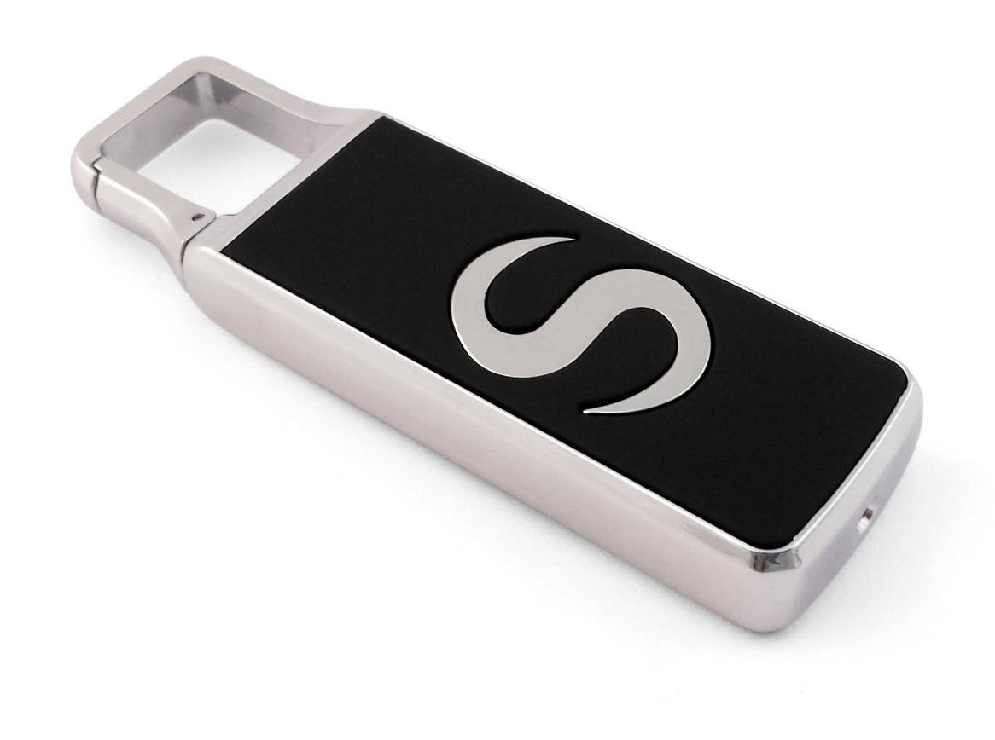

Contents
Package Contents 2
Before You Start 2
Overview 3
Controls 3
SD Card Slot (TF) 3
USB: Syncing and Charging 3
Power / Capture 4
Turn On 4
Turn Off 4
Mode 4
Video Mode 4
Photo Mode 4
Audio Mode 4
Motion Detection Video 4
Timestamp Edit 5
Webcam Mode 6

Package Contents
• S-Cam Spy Keyring
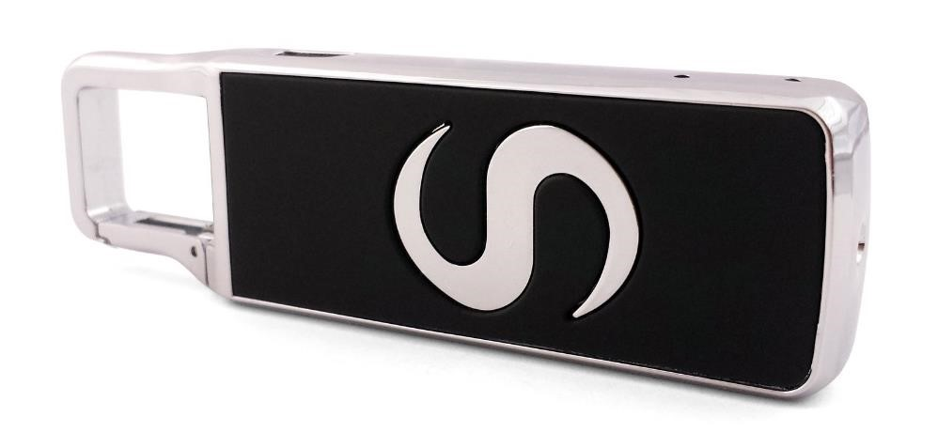

Before You Start
Make sure you have charged the device for 8 or more hours prior to full use.
It is recommended that you charge for 24 hours; however we know this is not always possible.
Turn over for charging instructions…

Overview
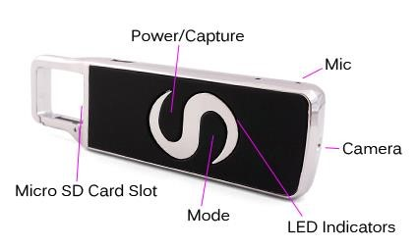
Figure 1 Figure 1 shows the controls that the S-Cam uses.

Controls

SD Card Slot (TF)
You are able insert a Micro SD card (TF) up to 32GB into the S-Cam.
When holding the S-Cam (S facing forward) the Micro SD slot is at the base of the clip. Make sure the Micro SD card text is facing up so the contact points are facing down (Figure 2). The Micro SD Card should click in to place and sit flush to the edge of the S-Cam.
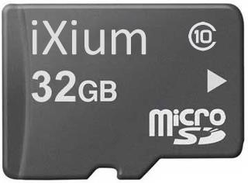
Figure 2

USB: Syncing and Charging
Supplied with the S-Cam is a USB cable which enables you to charge the battery and transfer the files that are saved on the Micro SD Card.

Power / Capture

Turn On
Press and hold the Power / Capture button until you can see the indicator has turned red (this should only take 2 or 3 seconds).

Turn Off
Press and hold the Power / Capture button until you can see the indicator goes out (this should only take 2 or 3 seconds).

Mode
This button enables you to switch between the different modes that the S-Cam is equipped with:
- Video (timestamp)
- Photo (no timestamp)
- Audio
- Motion Detection Video (timestamp)

Video Mode
Turn the S-cam on. Once the indicator has turned red quickly press the Power / Capture button and the indicator will flash and then go out. It is now recording video.
When you are done recording video quickly press the Power / Capture button. The video has now stopped recording and the S-Cam is ready to use again.

Photo Mode
Turn the S-cam on. Once the indicator has turned red quickly press the Mode button; the red indicator will flash a moment, this means it is ready to take a photo. Quickly press the Power / Capture button to take a photo; the indicator will go out momentarily and come back on when ready to take the next picture.

Audio Mode
Turn the S-Cam on. Once on, go to photo mode and then quickly press the mode button again to switch in to audio mode; the indicator will now have gone from red to blue. To start recording audio quickly press the Power / Capture button, the indicator will flash a go out.
When you are done recording audio quickly press the Power / Capture button. The audio has now stopped recording and the S-Cam is ready to use again.

Motion Detection Video
Turn the S-Cam on. Once on, go to audio mode and then quickly press the mode button again to switch in to motion detection video mode; the indicator will now have gone from blue to red and blue. To start recording in motion detection video quickly press the Power / Capture button, the indicator will flash a go out.
When you are done recording motion detection video quickly press the Power / Capture button.
The video has now stopped recording and the S-Cam is ready to use again.

Timestamp Edit
You may need to update the internal clock for the timestamp shown in images and videos.
To do this, you will need to create a Text file with the date and time.
- Plug the camera into your computer by using a USB cable.
- It will appear as a Removable Disk.
- Open the Removable Disk; you might have some folders and a text file called “time” already there.
- If you already have a file called “time” then move onto Step 7.
- Right click in the white space and a menu will appear (Figure 3), move down to “New” and select “Text Document”.

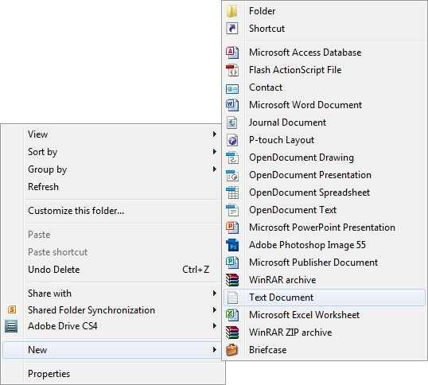
Figure 3
- A new Text document will appear (Figure 4) and give you the option to name it, call it “time”.
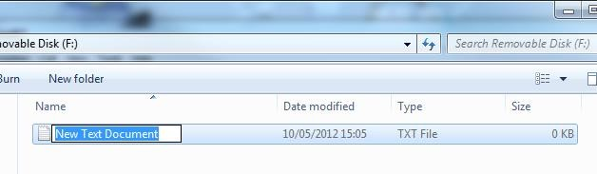

Figure
4

- Open this time file and write the date and time in the following method:
2010-01-26 10:10:59 (this is example only, use the correct date/time) 8) Save and close the file.
- Unplug the camera from the computer and turn it on. The time is now updated.
- Plug the USB Stick back into your computer and delete the time file if still there.

Webcam Mode
You can also use the S-Cam as a webcam for your computer. All you need to do is plug the S-Cam in to your computer, wait for it to appear as a removable disk like you would to view the files. Once you know you can view the files quickly press the Power / Capture button, this will turn the S-Cam in to a webcam for you.

(next page)

